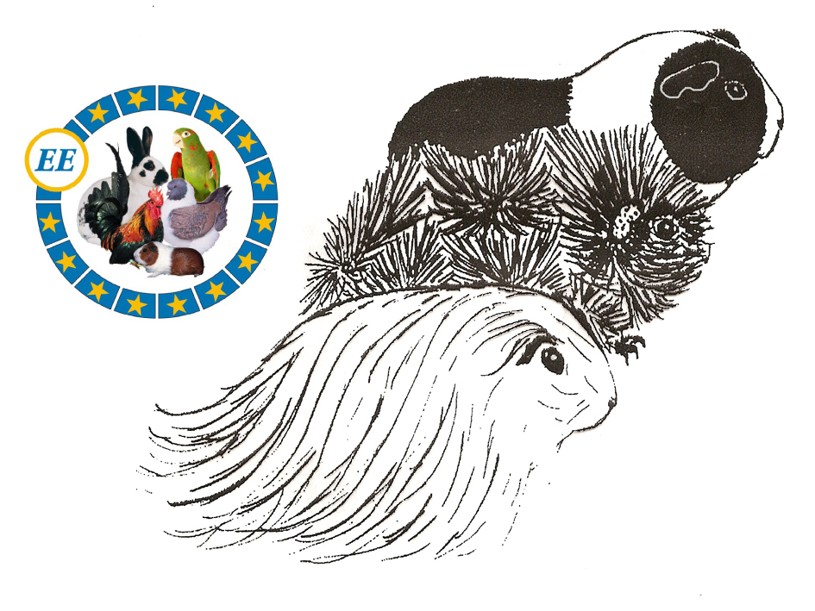
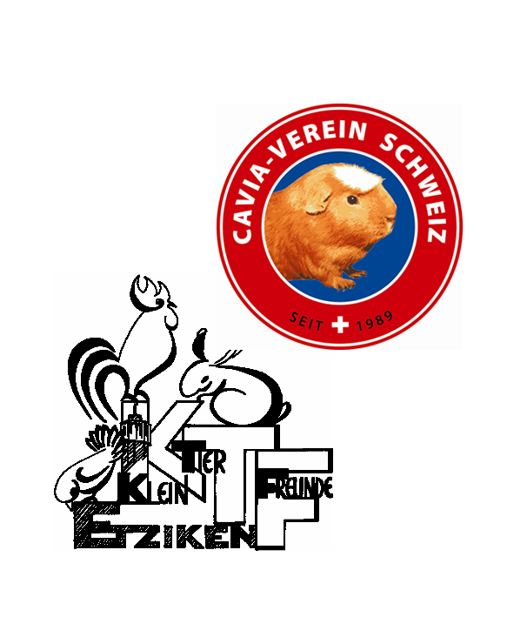

Entry Form
Breedspecific EE-Shows
14./ 15. May 2011 CH 4554 Etziken

Name + Christian name
Street, Postcode Town/Country

 and Email

I would like to assist as a helper: Booksteward / Steward /Feeding / Info/ Sale section

Breed: | Colour | M/F | Class  A/B/C/  E a/b/c | Pen nr.  Sec’s use
A-class = 9 months +, B-class 6-8 months, C-class 3-5 months / M = male (boar) / F = female (sow)
E-class: breeds and/or colours, not yet standardised in the European standard, age standardised cavies

I reserve |  | Sale pens | Entry fees’ totals
.. exhibits à € 4.00 / Fr. 6.00 |  |  |  | € |  | Fr.
………..Sale stock à € 2.00 / Fr. 3.00 |  |  |  | € |  | Fr.
Administration fee incl. souvenir |  |  |  | € | 8.00 | Fr. | 12.00
Catalogue obligatory (1 per household) |  |  |  | € | 4.00 | Fr. | 6.00
……x social evening with banquet à € 25.00 / Fr. 38.00 |  |  |  | € |  | Fr.
Breeders’ adverts à € 20.00-60.00 Fr. 30.00/ 90.00 |  |  |  | € |  | Fr.
Total |  |  |  | € |  | Fr.

All fees have to be transferred by 5. April 2011 to Euro account number:
61355.29 IBAN Nr. CH71 8097 1000 0061 3552 9 / EUR, SWIFT RAIFCH22
or CHFr-account 61355.23 Cavia-Verein Schweiz.

Touwn and date : Signature.......................

All entries (please write in block capitals or type) to be received by 01. April 2011:
Rösli Karpf, Hinterwilerweg 110, CH 4714 Aedermannsdorf
Or attached to an email to: roesli.karpf@sunrise.ch (only accepted after confirmation of receipt)

